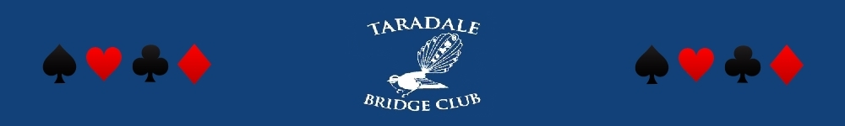

Taradale Bridge Club Incorporated
Chris Stack (President) 844 9983
Jan Davis (Secretary) 843 7066

P O Box 7051 Taradale, Napier 4141

March 2017 Newsletter

Hi Taradale Bridge Players

The club is holding a special meeting of all members this coming Sunday 19 March at 2pm in the club rooms. Afternoon tea is also arranged. The is only one item on the agenda to consider – the offer to purchase our Devonshire Place property. This property was the former club rooms up to eight years ago when we moved to the Taradale Club. It is vital that full members attend if at all possible – you have to be present to have your say and vote on the proposal. Please find also attached with this Newsletter, an information sheet regarding the proposal to purchase. John Sowerby, Jo Hayes, and I have been the subcommittee tasked with this project. Jo and I are happy to discuss with people individually if contacted.

New members – we wish to welcome to our club, including some of whom have recently moved into Hawke’s Bay. Lois Rodler, Chris Gibson, and Barry George (has arrived from Warkworth), have all joined as associate members.
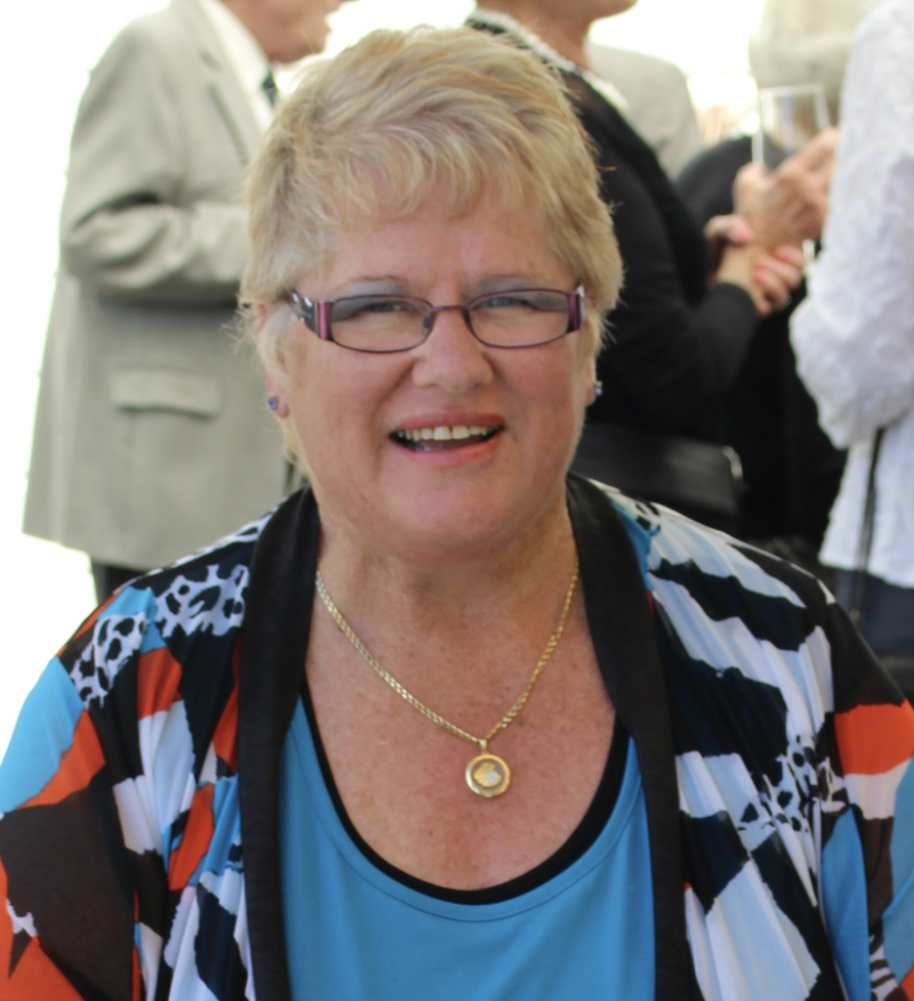
From the President’s Table – It was great to see so many tables at our recent intermediate tournament a great day was had and congratulations to our winners Judy Inzunau and Carol Fraser. Thanks to all those who came to help it makes things much easier with lots of help. Thanks especially to Rachel for all her hard work she does a great job. Please remember to come to our special meeting 2 pm March 19th it is important we make a decision and you cast your vote. Please remember you have to be a full member to vote and according to the constitution we need 25 members present and 75% voting for or against to carry the vote. A big thanks to the subcommittee for their hard work Jo, Ash, and John. Chris Stack
Chris Stack - President
Bridge Lessons – A reminder of the Taradale Club’s Beginner Lessons that start on 23 March. For further details visit our website http://www.taradalebridgeclub.org.nz/

Upcoming tournaments, being run by Taradale Bridge or local Clubs - our club is most fortunate to have Rachael Shaw as our tournament secretary.
- 18 March Greenmeadows New World Lawson Jugs 8B, with 10 tables of players at least currently entered.
Also
- 25 March Open Teams, Hastings 5A
- 9th April (Sunday) Napier Dunstalls 5B Intermediate Hetley Trays Tournament 5B. This is for all Intermediate and Junior players with generous prizes. There will also be a prize for top. junior pair if more than one pair entered. See attached Flyer for further information

Taradale Club Website – for those who are unaware, the website can be opened at http://www.taradalebridgeclub.org.nz/. This is regularly updated with Committee minutes, club and tournaments results, photos, and other relevant information.

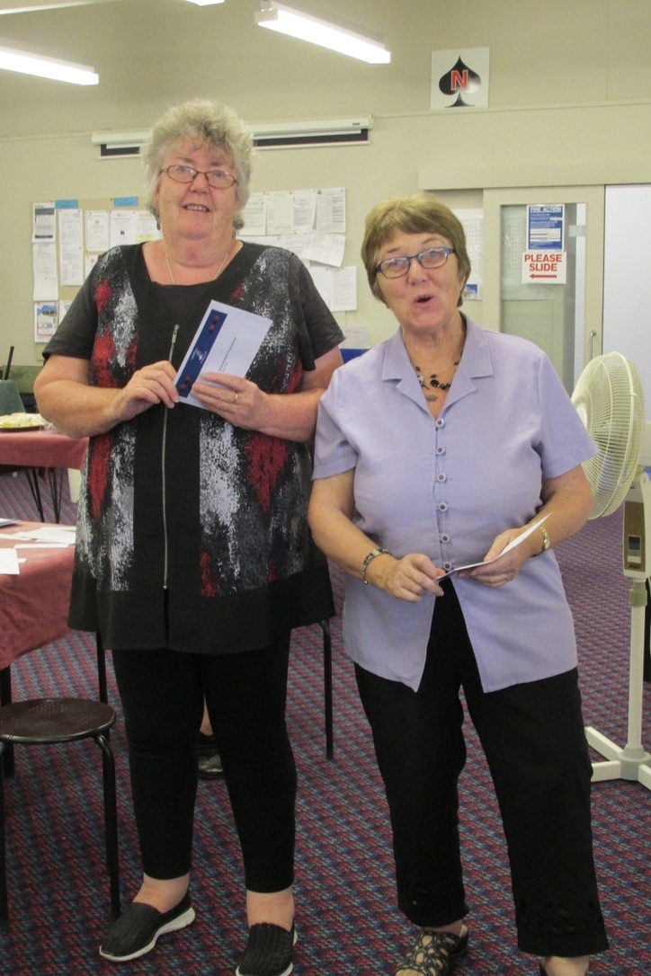
Club Bridge Results – as you are no doubt aware several bridge sessions have the winners accumulated over the whole year i.e. Monday morning; Tuesday afternoon, and Thursday afternoon. The other bridge sessions are accumulated over a month and the recent results for those have the following winners of the month.
Competition | Winners
New Partner Pairs Wednesday night (February) | 1st Trish Peters and Ash Fitchett  2nd Robyn Anderson and Jo Hayes
Taradale Intermediate Pairs Tournament Sponsored by Mike Smith of Harcourts | 1st Carol Fraser and Judy Inzunza
The first Taradale tournament for 2017 was run on 4 March and it was great to see the Taradale pair, Judy and Carol come out on top of the 28 pair strong field. A great effort also by Rachael to gather the large number of tables.
Judy Inzunza and Carol Fraser, winners of the Mike Smith Intermediate tournament

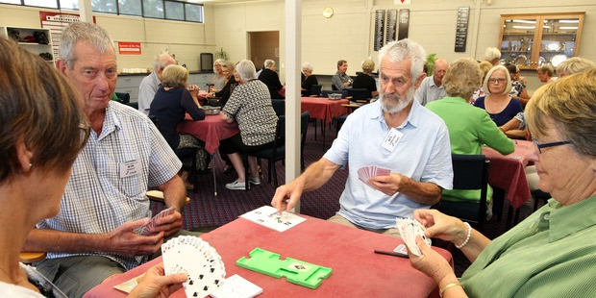
Gold Coast Congress Report! Many of you will have either seen or heard about the Hawkes Bay Today newspaper article about the Congress. The photo included with the article (and the link to the actual article) is shown on the left. http://www.nzherald.co.nz/hawkes-bay-today/sport/news/article.cfm?c_id=1503460&objectid=11802884
Sheryn Thomson (left), Alan Haslett, Ken Carmichael and Lavinia Hart are part of the 19-member Taradale club players off to the Gold Coast Bridge Congress

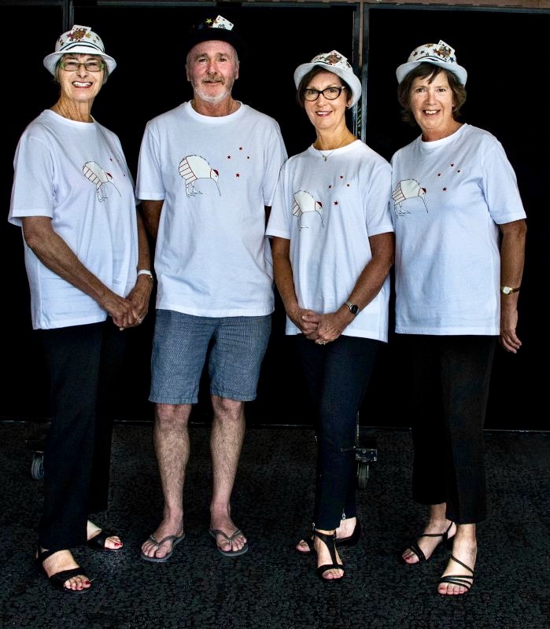
Julie Haslett has written an entertaining report from the Congress, especially to tempt those perhaps considering playing there in the future.
Alan and I always look forward to February, this year was no exception! Fourteen plus excited bridgies from Hawkes Bay started our adventure at the Napier Airport on Friday morning the 17th Feb. A couple of internal flights to Auckland were delayed or cancelled, consequently we missed our flight to the Gold Coast. Off to Brisbane we flew and had to be shuttled down to Broad Beach courtesy of Air N.Z for mucking us around! We arrived at our respective apartments at 6.30 pm very tired, but after the Duty Free was unpacked the situation improved considerably!
Jan Davis, Haden Seal, Sheryne Thomson, and Ruth Spittle dressed in theme for the teams event.
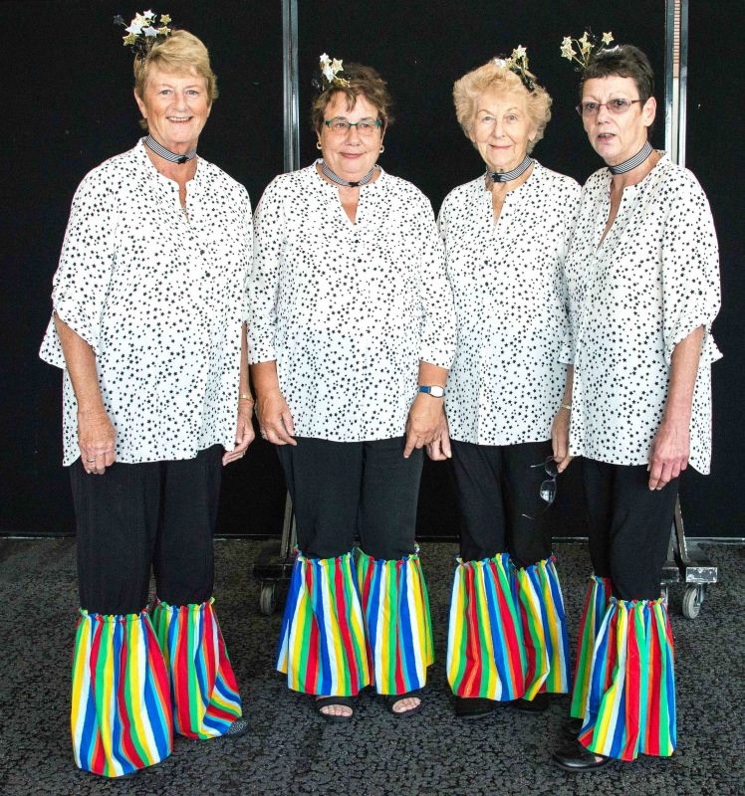
Saturday afternoon was the start of the pairs so it was swimming in our lovely pool and a bit of shopping in the morning – wonderful! The Convention centre we played in was an amazing space, if you can imagine 2,500 people in one room and it was only ¼ full of what it can accommodate at one time. All the different sections are marked out with a flag so you know where to sit, there were so many rows though so you needed a “landmark” at the beginning of the row, I chose a lady with bright red hair, fortunately she was sitting most of the time! The organisation of the congress is next to none, there are so many helpers, advisers and directors. The boards are always there for you to play and a watchful eye is kept on all players throughout the session! After 3 days of pairs the “cream” had risen to the top! There were 5 different grades, open, senior, intermediate, restricted, novice and rookie. A lot of us played in the Restricted grade, Yvonne Whittle and Francey Rolls were second in our grade out of 140 pairs, what a great achievement! The next three days was the teams event. Each year they have a theme you have to dress as, this year it was stars and stripes! Ngaire Crow put all the effort into our costumes, we didn’t win, but I think we looked great!
Trish Patterson, Ngaire Crow, Janice Willoughby, and Julie Haslett in the Gold Coast team competition
Thursday was my birthday and I must thank my Napier friends for making it so memorable – a big chocky cake a few more duty free’s, a game of charades in our apartment made for a fun night. (Ask Yvonne W. about Pussy Willow)
There were all types of events for the next couple of days if you chose to play, some of us did some retail therapy, we caught up with family from Brisbane!
All the players were very friendly, OK one or two pairs were a bit precious, but that can be part of our game! Trish and I were amazed at the amount of young guys we played against coming up through the ranks, some as young as 13,14. The winners of the open finals were young guys, so bridge is being taken up by our young people, which is very heartening.
Look forward to seeing you at Broadbeach next February!
Julie Haslett

Devonshire Place Property – As has been mentioned above, we have formally given 28 days’ notice of a Special Meeting of the Taradale Bridge Club to consider the offer to purchase this property. Please ensure you read the attached information sheet that looks at the financial and other associated considerations for all members to read and understand prior to the meeting. A decision is required either way, at this meeting.

Bridge Rules & Etiquette – this month we will touch on the required tempo for bidding and playing. I personally learnt a valuable lesson from a grand master some years ago at the New partner pairs in Napier. I hesitated then passed, much to my partner’s disgust (there was 4S our way). My partner threw their hand down on the table and said “Ash your hesitation has forced me to pass”. I probably left the table at about 5ft in height but learnt a valuable lesson!
Tempo / Hesitations
- Acquire the habit of playing smoothly and in tempo. Avoid mannerisms, meaningful eye contact, sighs, grimaces and using extra words such as “I guess I need to pass”.
- Avoid hesitations by being consistent and deliberate in your bidding. A hesitation followed by a pass places an extra burden on partner to justify continuing with the bidding as this may have communicated information to partner.
- If you have a difficult decision you have a right to think, but partner cannot take advantage of the knowledge that you had a problem. So, if your partner takes time to bid or bids out of tempo and then passes, you should pass too, unless that action would be totally illogical considering your hand.
Clarification of Quitted Trick
- A quitted trick is when all cards for a trick are placed face down. Until a player faces their own card down, that player is entitled to inspect cards faced down by other players. After facing a card down, a player may inspect their own card until their side has led or played to the next trick.

Committee Meeting News – from the meeting held on Tuesday 14 March
- The Thursday morning sessions are running at 10-12 tables and recently has run well on time. Great to see and it was decided to monitor the finishing times
- Directors exams dates are 15-16 July 2017 – if any member is interested in becoming a Director please contact a committee member. The committee is keen for new Directors and will cover any reasonable costs associated with the exam.

Honest Answer

Two little old ladies were playing in a tournament against two celebrated masters. One of the ladies opened the bidding with one no trump.
The master to her left was looking at a hand containing 14 points on which he considered bidding. He turned to the opening bidder's partner and asked, "What range of no trump do you play?"
"Strong," she answered, "around 20 points."
Whereupon the master hastily passed and so did the opening bidder's partner. Dummy laid down 2 queens and a jack and the expert silently congratulated himself for not having stuck his neck out.
But the defense started to take trick after trick and eventually accumulated 9 of them beating the contract by 3, un-doubled. Game was cold in the masters' hand.
The expert with the 14 point hand turned to the dummy and said in an aggrieved tone, "Didn't you say you played a strong no trump?"
"I do," answered the little old lady. "But my partner plays a weak no trump, about 12 points."

Thank you – for the various helpers within the club and their spouses for their contributions towards the club. This month Sue Tarrant deserves a special mention for her dedicated sending of the weekly bridge results to the Hawke’s Bay Today Newspaper so they appear in the Friday paper. Sue also is always there early on Wednesday night to set up the tea and coffee for the players, and is first to offer to assist with the running of the tournaments. Thanks for continuing to be a great contributing member.

Reminders
- Special Taradale Bridge Club meeting – Sunday 19th March at 2.00pm
- Lawson Jugs tournament 18th March
- Beginner Lessons starting 23rd March

Ash

Ash Fitchett (Newsletter Scribe)

